# Problem 1

#Main

maindir = 'E:\SIT\CS558\cs558s18_hw4\cs558s18_hw4\ImClass';

subdir = dir( maindir );

for i = 1 : length( subdir )

subdirpath = fullfile( maindir, subdir( i ).name, '*.jpg' );

dat = dir( subdirpath ) ;

for j = 1 : length( dat )

datpath = fullfile( maindir, subdir( i ).name, dat( j ).name);

image{j} = double(imread(datpath));

end

end

%%

bin = 8;

image_rep = rep_image(image,bin);

train = image_rep([5:8,13:16,21:24],:);

y = [1;1;1;1;2;2;2;2;3;3;3;3]; %1 is coast, 2 is forest, 3 is incidecity

test = image_rep([1:4,9:12,17:20],:);

test_y = [1;1;1;1;2;2;2;2;3;3;3;3];

%%

wrong = 0;

test_size = size(test,1);

for i = 1: test_size

k = dsearchn(train, test(i,:));

fprintf('\nTest image %d of class %d has been assigned to class %d.\n', i, test_y(i),y(k));

if test_y(i)~=y(k)

wrong = wrong + 1;

end

end

accuracy = (test_size-wrong)/test_size;

fprintf('\nAccuracy is %.2f', accuracy);

pause;

%%

bin = 1:64;

accuracy = zeros(length(bin),2);

accuracy(:,1) = bin;

for i = 1:length(bin)

image_rep = rep_image(image,bin(i));

train = image_rep([5:8,13:16,21:24],:);

test = image_rep([1:4,9:12,17:20],:);

accuracy(i,2) = cal_accuracy(train,test);

end

plot(accuracy(:,1),accuracy(:,2));

ylim([0.5,1]);

pause;

#hist

function RGB_vector = hist(X, bin)

RGB_vector = zeros(3*bin,1);

for i = 1:3

RGB_vector((i-1)*bin+1:i*bin,:) = histcounts(X(:,:,i),bin);

end

end

#rep_image

function image_rep = rep_image(X,bin)

image_rep = [];

for i = 1:length(X)

p = cell2mat(X(i));

RGB_V = hist(p,bin);

image_rep(i,:) = RGB_V';

end

end

#cal_accuracy

function accuracy= cal_accuracy(train,test)

wrong = 0;

test_size = size(test,1);

y = [1;1;1;1;2;2;2;2;3;3;3;3];

test_y = [1;1;1;1;2;2;2;2;3;3;3;3];

for j = 1: test_size

k = dsearchn(train, test(j,:));

if test_y(j)~=y(k)

wrong = wrong + 1;

end

end

accuracy = (test_size-wrong)/test_size;

end

#Result

Test image 1 of class 1 has been assigned to class 1.

Test image 2 of class 1 has been assigned to class 1.

Test image 3 of class 1 has been assigned to class 1.

Test image 4 of class 1 has been assigned to class 1.

Test image 5 of class 2 has been assigned to class 2.

Test image 6 of class 2 has been assigned to class 2.

Test image 7 of class 2 has been assigned to class 2.

Test image 8 of class 2 has been assigned to class 2.

Test image 9 of class 3 has been assigned to class 2.

Test image 10 of class 3 has been assigned to class 1.

Test image 11 of class 3 has been assigned to class 3.

Test image 12 of class 3 has been assigned to class 3.

Accuracy is 0.83

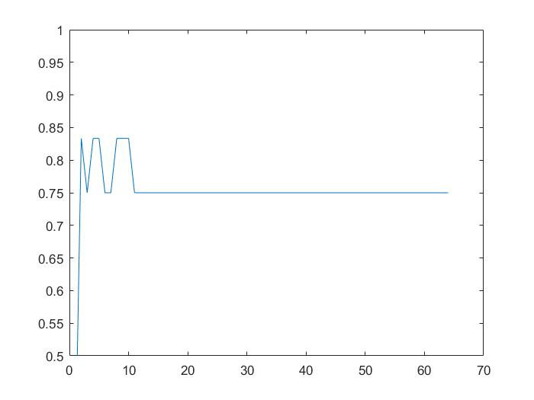

The bin size doesn’t influence accuracy significantly.

# 

# Problem 2

#Main

%% Load training image

sky_train = double(imread('sky.jpg'));

ground_train = double(imread('ground.jpg'));

sky_test1 = double(imread('sky_test1.jpg'));

sky_test2 = double(imread('sky_test2.jpg'));

sky_test3 = double(imread('sky_test3.jpg'));

sky_test4 = double(imread('sky_test4.jpg'));

%% k-mean

k = 10;

sky_train_kmean = reshape(sky_train, [256*256,3]);

ground_train_kmean = reshape(ground_train, [256*256,3]);

[id_sky,sky_cent] = kmeans(sky_train_kmean, k, 'EmptyAction', 'singleton');

[id_ground, ground_cent] = kmeans(ground_train_kmean, k, 'EmptyAction', 'singleton');

%% test

[sky1, ground1] = split_sky_ground(sky_test1,sky_cent,ground_cent);

[sky2, ground2] = split_sky_ground(sky_test2,sky_cent,ground_cent);

[sky3, ground3] = split_sky_ground(sky_test3,sky_cent,ground_cent);

[sky4, ground4] = split_sky_ground(sky_test4,sky_cent,ground_cent);

%% Show the picture

subplot(1,4,1);

imshow(uint8(ground1));

subplot(1,4,2);

imshow(uint8(ground2));

subplot(1,4,3);

imshow(uint8(ground3));

subplot(1,4,4);

imshow(uint8(ground4));

# split_sky_ground

function [sky,ground] = split_sky_ground(X,sky_cent, ground_cent)

[m,n,k] = size(X);

sky = zeros(size(X));

ground = zeros(size(X));

for i = 1: m

for j = 1:n

p = reshape(X(i,j,:),[1,3]);

d_sky = mean(sqrt(sum((p - sky_cent).^2,2)));

d_ground = mean(sqrt(sum((p - ground_cent).^2,2)));

if d_sky < d_ground

sky(i,j,:) = X(i,j,:);

else

ground(i,j,:) = X(i,j,:);

end

end

end

#Result

